APPROVAL FORM
ACADEMIC & EXAMINATION BOARD

REQUEST DETAILS
Requestor | Radhika | Date | 18/08/2026
Department | Academics | Nature of request | Retest
Olrick and Luke from P6 Grit did not meet the requirements for PT1 (Composition). Both students were unable to complete the composition and therefore received 0 marks.

ACADEMIC AND EXAMINATION BOARD REVIEW
Date |  | Decision
Implementation date (if applicable) |  | Remarks
BOARD RESOLUTION
APPROVED BY (AEB MEMBERS)
Cacananta, Ninalyn Sulit Gary Cacananta Villamor, Norma Bardos

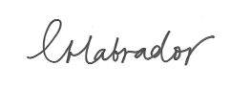
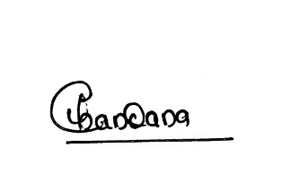

Labrador, Christina Bacolor Chandana Letha Dileep

IMPLEMENTATION AND EFFECTIVITY CHECKLIST (To be done by the requestor)
- Information cascading
- Update of records / policy
- Pull out of old document (If necessary)
- Effectivity Check Report
  - 1st month: ___________________________________________________________________
  - 2nd month: ___________________________________________________________________
  - 3rd month: ___________________________________________________________________
  - 4th month: ___________________________________________________________________
  - 5th month: ___________________________________________________________________
  - 6th month: ___________________________________________________________________

